Name: _____________________________________ Class: _____________________ Date: _____________
Page 413
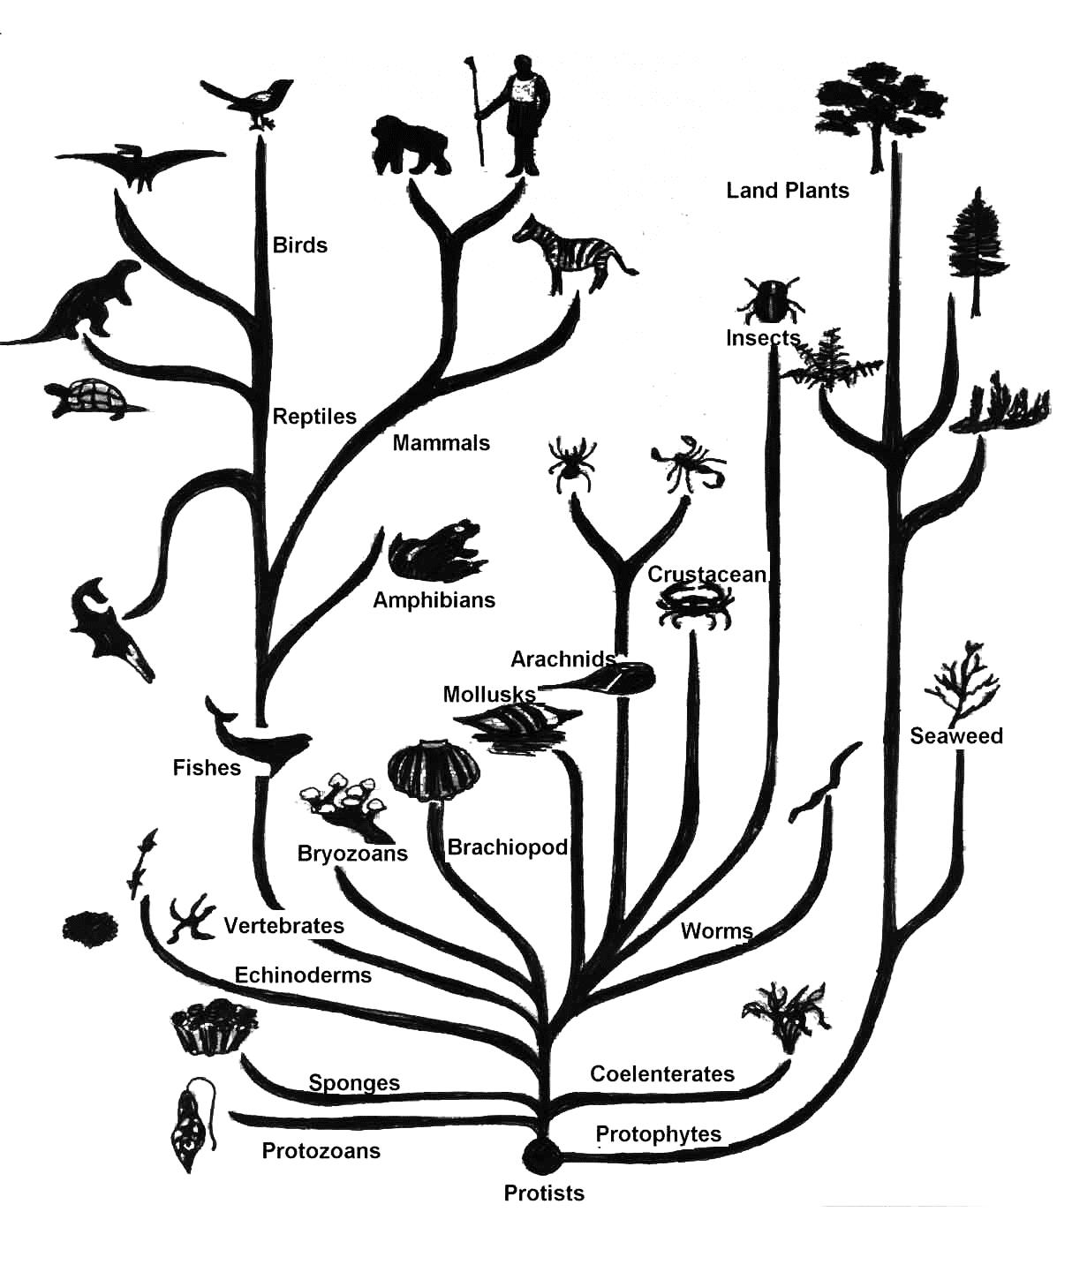
Darwin’s Evolutionary Tree
*This particular drawing of Darwin’s Evolutionary Tree was published in 1968 by Nicholas Hotton III. It is popular because of its clean, simple look. Although, as with most drawings, it is, of course, an oversimplification.

