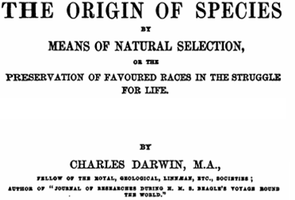
When on board my ship, the H.M.S. Beagle, I was surprised by the distribution of the inhabitants of South America, and in the geological relations of the present to the past inhabitants of that continent. These facts seemed to me to throw some light on the origin of species—that mystery of mysteries, as it has been called by one of our greatest philosophers.
On my return home, it occurred to me that something might perhaps be made out on this question. And so I began to patiently reflect upon all sorts of facts which could possibly have any bearing on it. After five years of work, I allowed myself to speculate on the subject, and from that period to the present day I have worked to develop my theory.
In considering the Origin of Species, it is quite conceivable that a scientist, reflecting on all living things (on their embryological relations, their geographical distribution, geological succession, and other such facts) might come to the conclusion that each species had not been independently created, but had descended from other species. Nevertheless, such a conclusion, even if well founded, would be unsatisfactory, until it could be shown how the many species inhabiting this world have been modified, so as to acquire the perfect structures and adaptations which we see today.
Scientists continually refer to external conditions, such as climate, food, etc., as the only possible cause of variation. But it is preposterous to attribute to mere external conditions, the structure, for instance, of the woodpecker, with its feet, tail, beak, and tongue, so admirably adapted to catch insects under the bark of trees.
Religious folk, I presume, would say that at some point, some bird had given birth to a woodpecker, and that they had been produced perfectly as we now see them. But this, to me, is not a proper explanation.
Adapted for 8th Grade by Nicholas Amendolare
When I began my observations, it seemed likely that a careful study of animals and of plants would offer the best chance of finding the correct explanation. In particular, I was reminded of my observations of the finches of the Galapagos Islands.
Upon visiting the islands, I observed that the various islands each had unique species of finches. And each finch seemed uniquely adapted to its environment. And so I wrote, “Seeing this diversity in one small group of birds, one might think that from an original group of birds on these islands, one species had been taken and modified for different ends.”
It seems clear to me now that the finches did arise from one species of birds. And that they were modified, not by some person, but by a process of natural selection. Those finches who were best suited for their island would, of course, reproduce and pass on their best traits. It would be survival of the fittest, and the death of the weakest.
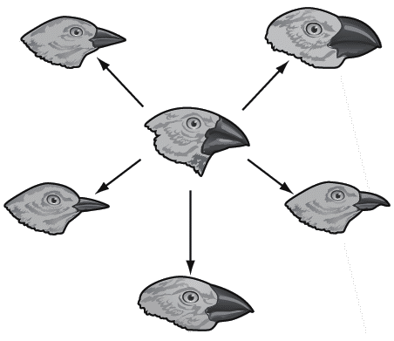
No one ought to feel surprised at this explanation. We have much to learn in regard to the mutual relations of all the beings which live around us. Who can explain why one species ranges widely and is very numerous, and why another allied species has a narrow range and is rare? Yet these relations are of the highest importance. They determine the present welfare, and the future success, of every inhabitant of this world.
And we know even less about the plants and animals of the many past ages in its history. Until now, most assumed that each species had been independently created. I have no doubt, after many years of study, that this belief is incorrect. I am fully convinced that species are not immutable; they are always changing. And those similar species are actually descendants of some other long-extinct species. And in the same manner as the finches, the acknowledged varieties of those species arose with time. Furthermore, I am convinced that Natural Selection has been the main means of modification, of all life, throughout Earth’s history.

