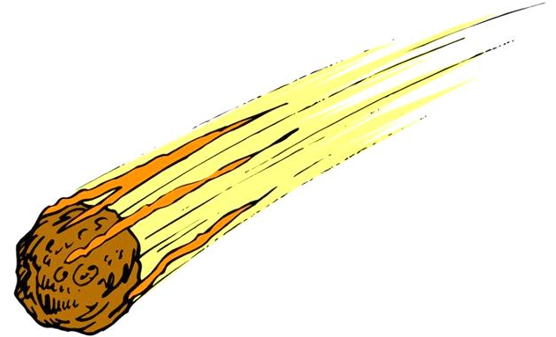
Name: _____________________________ Class: ______________________________ Date: _________
Page 516
Armageddon?

Instructions:
- Go to https://www.desmos.com/calculator
- Graph the equation for Earth’s orbit, found below.
- Graph the equation for one of the asteroids below.
- If the asteroid CANNOT impact Earth, move on to another.
- If the asteroid CAN impact Earth, fill out a Warning Slip and pass it in to the NASA mailbox.

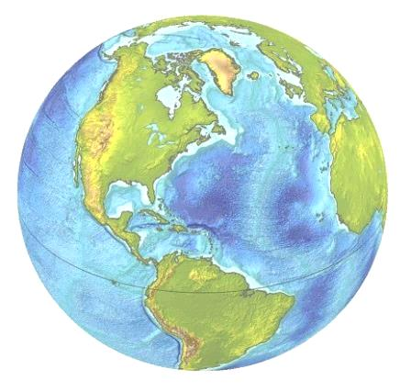
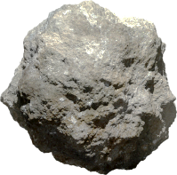
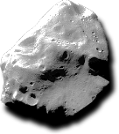
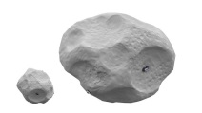
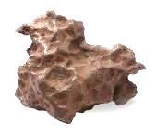
Earth
$$\frac{x^{2}}{{149}^{2}}+\frac{y^{2}}{{152}^{2}}=1$$
Diameter = 6,371 km
Mass = 6.97x10²⁴ kg
4 Vesta
$$\frac{x^{2}}{{322}^{2}}+\frac{y^{2}}{{384}^{2}}=1$$
Diameter = 505 km
Mass = 2.59x10²⁰ kg
433 Eros
$$\frac{x^{2}}{{169}^{2}}+\frac{y^{2}}{{267}^{2}}=1$$
Diameter = 34 km
Mass = 6.69x10¹⁵ kg
1566 Icarus
$$\frac{x^{2}}{{294}^{2}}+\frac{y^{2}}{{28}^{2}}=1$$
Diameter = 1.4 km
Mass = 2.9x10¹² kg
2003 EH₁
$$\frac{x^{2}}{{756}^{2}}+\frac{y^{2}}{{178}^{2}}=1$$
Diameter = 4 km
Mass = 4.5x10¹² kg

624 Hektor
$$\frac{x^{2}}{{612}^{2}}+\frac{y^{2}}{{184}^{2}}=1$$
Diameter = 370 km
Mass = 9.9x10¹⁸ kg
163693 Atira
$$\frac{x^{2}}{{75}^{2}}+\frac{y^{2}}{{147}^{2}}=1$$
Diameter = 2.5 km
Mass = 1.0x10¹² kg
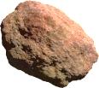
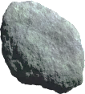

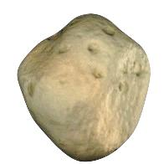
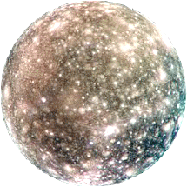
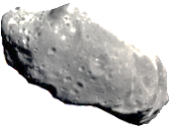
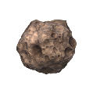
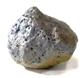
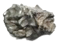
According to NASA, there are roughly 150,000,000 asteroids in the solar system. It’s really just a matter of time…
3362 Khufu
$$\frac{{(x-80)}^{2}}{{217}^{2}}+\frac{y^{2}}{{79}^{2}}=1$$
Diameter = 700 m
Mass = 3.2x10¹¹ kg
2008 TC₃
$$\frac{x^{2}}{{135}^{2}}+\frac{{(y+51)}^{2}}{{257}^{2}}=1$$
Diameter = 4.1 m
Mass = 8.0x10⁴ kg
20461 Dioretsa
$$\frac{x^{2}}{{357}^{2}}+\frac{y^{2}}{{6752}^{2}}=1$$
Diameter = 14 km
Mass = unknown
99942 Apophis
$$\frac{x^{2}}{{112}^{2}}+\frac{y^{2}}{{164}^{2}}=1$$
Diameter = 325 m
Mass = 4.0x10¹⁰ kg
136199 Eris
$$\frac{x^{2}}{{5668}^{2}}+\frac{y^{2}}{{14600}^{2}}=1$$
Diameter = 2,326 km
Mass = 1.67x10²² kg
1 Ceres
$$\frac{x^{2}}{{382}^{2}}+\frac{y^{2}}{{445}^{2}}=1$$
Diameter = 950 km
Mass = 9.4x10²⁰ kg

